08
Fall
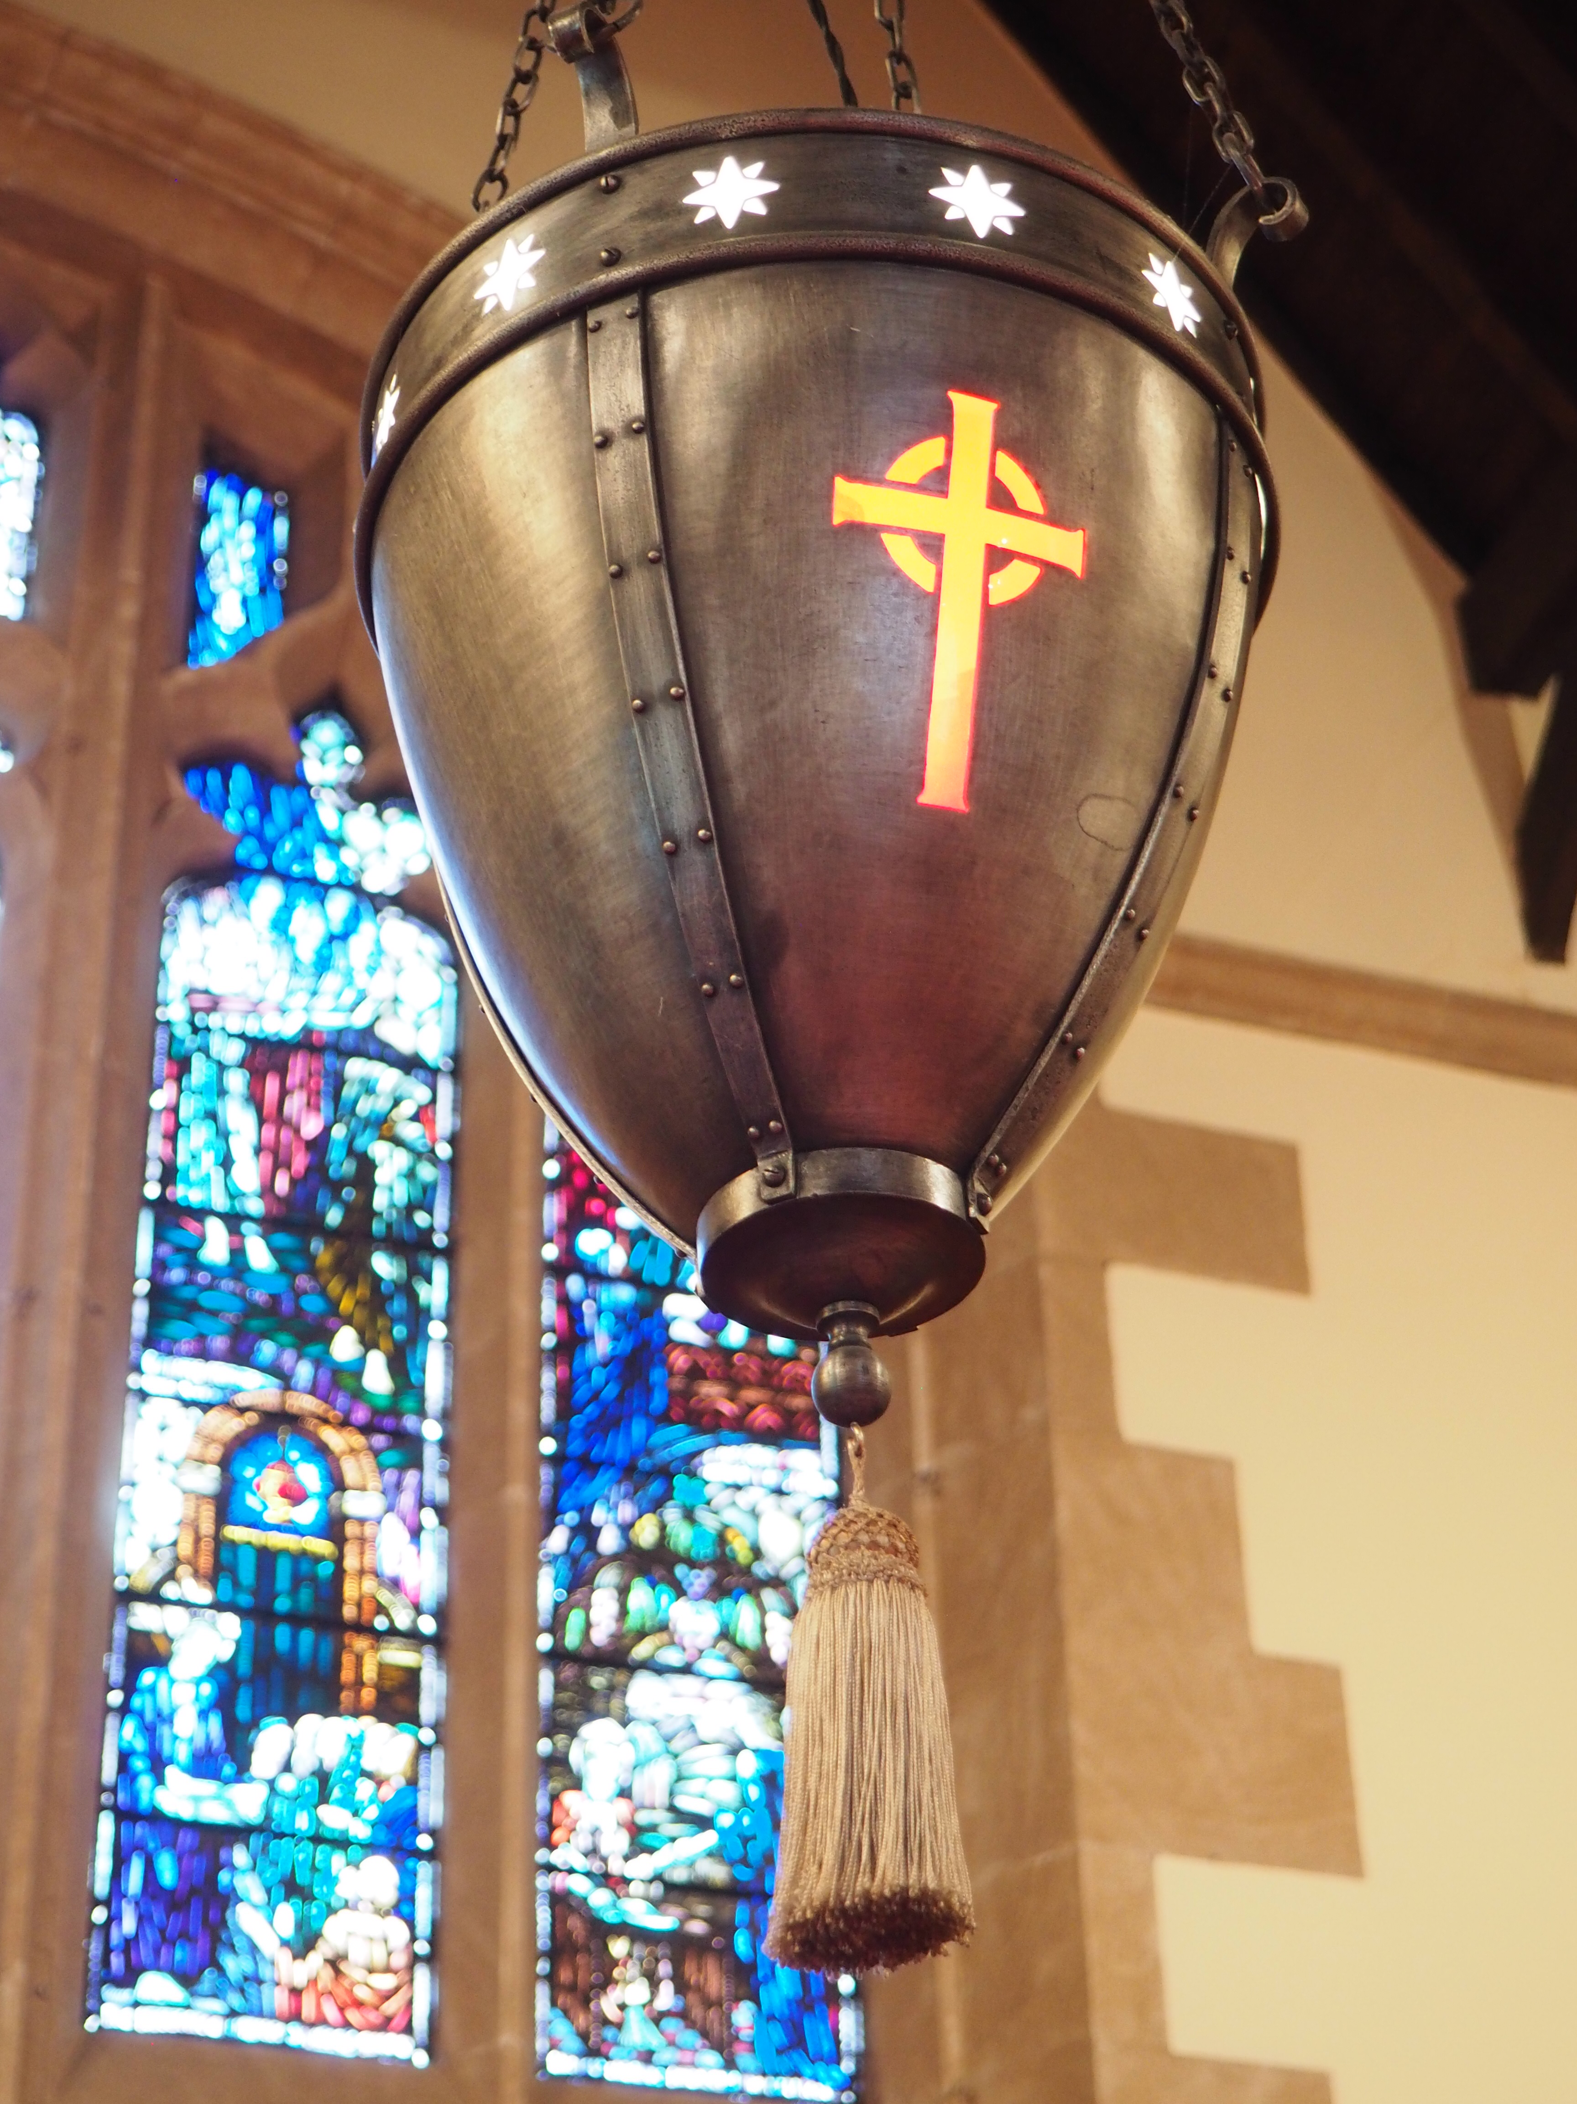 | THE  RECORD

February

2020

A Word from your Minister

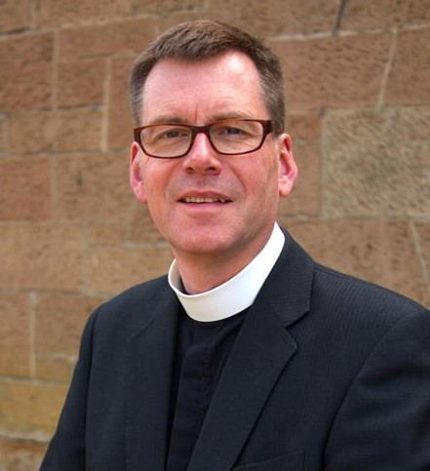

Out of the fires...

I suspect all of us have been shocked at the images from south-east Australia, where wildfires have spread uncontrollably across an area now approaching the size of Scotland, destroying homes and farms, towns and livelihoods, decimating the indigenous wildlife and, very sadly, taking a toll in human lives, too.
While there are clearly big questions to address around climate change and the global conditions which have enabled these fires - and others in the Amazon - to take hold and spread with astonishing rapidity, I’d like to focus instead on the issue of common humanity and a concern for community.
For amid the tales of disaster there are many stories of heroism and a commitment towards neighbours which is deeply touching. On Hogmanay, the fire reached the town of Mallacoota where residents and tourists were forced to flee to the beach as the flames came ever nearer. Kelly Dubberley, a carpenter to trade and presently out of work as a result of the crisis, offered to help build a new enclosure for koalas at the temporary animal hospital. “You just want to help out,” he said.
In Matthew’s Gospel, Jesus expands the understanding of the Law prevalent in his time. Loving neighbours is one thing, Jesus says, but he goes on to encourage a radically broader idea: that we should also love our enemies. There aren’t enemies in the fire-ravaged towns of Australia but I’m sure before the flames people didn’t necessarily show generous love to those around. There simply wasn’t the need.
Although the situation there is desperate, it is encouraging to see that something in the human spirit reaches out more broadly than family and friends. Strangers make meals, share clothes, offer a place to stay – or help the remaining wildlife keep safe. Perhaps it takes a challenge such as this for people to pull together.
Jesus suggests this generous, other-centred way of living should be more the norm than the exception. Could we take him at his word – and what might happen globally if we all had a deep concern to act in ways which do good and not harm to our neighbours, our nation, and the generations to come?

Your Minister
Grant Barclay.

On the Cover

Illuminating the chancel with love.

John 4:12

No one has ever seen God; but if we love one another, God lives in us and his love is made complete in us.

“Love many things, for therein lies the true strength, and whosoever loves much performs much, and can accomplish much, and what is done in love is done well.”
Vincent Van Gogh

Orchard Cafe

The Orchard Community Café is closed during the school holiday on Tuesday 11 February but will reopen on Thursday 13 February.

Guild Syllabus 2020
Guild Theme: “Companions on the Road”

The Guild meets on Monday afternoons at 2pm in the Fellowship Room.

Mon 24th Feb (2pm) Mr Archie Hunter
Mon 9th March (2pm) “Castlemilk House and the Stirling-Stuart Family” – Mr Iain Lowdon
Mon 23rd March (2pm) Musical Bingo

Reading the Bible in a year.
In 2019 a number of our congregation undertook to Read the Bible in a Year. Over the coming months each of the readers will write a short article about their experiences and their thoughts post reading.

This is the first review.

Before starting this challenge, I felt rather inadequate. Other people in different religions seemed to speak with authority about their faith. I always thought that not having read the whole Bible put me at a disadvantage. What if someone challenged me about my faith? When I heard that some people from Orchardhill were reading the Bible in a year, in bite-size pieces, I thought I’d give it a go.
However, when I showed up for what I thought was the first meeting I found out that it was actually the second! The rest were already a quarter of the way on the journey! Grant encouraged me to have a go, and try to catch up. I was up for the added challenge!
There was a reading plan – and it was very good. It provided the chapters to read, five sets for five days in the week which included some chapters from both the Old and New Testaments; peppered in each of the middle three days was a Psalm. Five sets of readings each week allows for what I would call slippage! Or missed days.
I quickly got involved in the bible story through Genesis and Exodus – such an exciting tale right at the beginning was a great hook and I quickly settled into the rhythm of reading the chapters. Some days I would read on to find out what happened next. As it progresses, the account becomes a bit gory: the all-victorious Israelite armies seem continually to wipe out nation after nation on their quest for the Promised Land. It sounds less like God loving everyone but, rather, only caring about a small group of former slaves. Finally, these people reach their Promised Land, but decide they can’t enter it - and wander in the desert for a further forty years!
The adjoining story in the New Testament started with the shortest of the Gospels, Mark, though soon we were into some of the deeper sides of the New Testament. Paul’s Letters to churches in various places are demanding and I was quite fortunate that for these three months I had time on my hands, relaxing away from home. I read quite a large part of the Bible using the plan set out, and that helped me understand the chronological order in which the books were written rather than just turning page after page.
By the next meeting, the halfway point in the year, I had caught up with the rest of the group and I felt better placed to join the discussions about different aspects of the narrative.
By now we were firmly committed to the team and to finishing the challenge! I did struggle with some of the chapters and felt I had lost the gist a wee bit - the same story seemed to repeat itself. In fact, as I later found out, many accounts in the Bible are repeated in different books – no wonder this left me slightly confused!
The theme running throughout the Old Testament is that God wants to have a relationship with this one people-group which grew into a nation: what we now know as the Israelites. However, they keep disobeying God and started worshipping other gods - and then there is a big fall out. God forgives them, all is well, but soon it all starts again. In the New Testament, this changes to God, through his Son Jesus, wanting to have a relationship with everyone and not just with one select group.
The New Testament is much more familiar and we all would know a good part of the Gospels. Again, though, there is much repetition - especially across Matthew, Mark and Luke. The books in which Paul sets out how the new church should be set up and run, are difficult to understand in places. Being such a weighty combination of works it would probably take a lifetime to read and study the whole Bible adequately. However, it is also beautifully written with many memorable phrases.
Looking back at my experience, I am very pleased that I did it. I’m also interested in further study to increase my understanding especially in areas where I perhaps lost my way a little. Part of the challenge was the need to read large sections, and this task differs considerably from intensively studying smaller parts.
Was this a worthwhile endeavour? Definitely. Would I do it again? Perhaps not with the complete Bible, though I would like to delve into some areas, not least to understand a bit more about Paul and what influences he had on the establishment of Christianity as we understand it today. Would I recommend others try this? Without hesitation. It brought a whole new dimension to my understanding and appreciation of the Bible.
Grant has already said that he would love to support another group if demand is there. What’s stopping you? Speak with Grant and you could read the Bible in a year. You will be glad you did it, as all of us are.

Badminton at Orchardhill
Were you a member of Orchardhill Senior or Junior Badminton Club? Or do you know friends or family members that were? If so, we want to hear from you!

In 2021 the Senior Club will be celebrating its 75-year anniversary; and 2019 saw the Junior Club having been run for 50 years! To mark these two landmarks of badminton in Orchardhill, we are organising a celebratory event and want to contact as many past members as possible. We already have lots of names but there are gaps and a number of people may have moved from the contact details we hold for them.

If you (or a family member or friend) were a member of either the Junior and/or Senior club at any time over the last 50-75 years, please pass your contact details to Shona Fisher (shona.fisher2@mail.com). Even if you have names of people you remember playing, please pass these on.

Tree of Kindness
Back in 2017 we started the Tree of Kindness, when Orchardhill Church partnered with KIND Scotland to help tackle the grave issue of poverty affecting so many people in Scotland. We live on the outskirts of Scotland’s largest city where 37% of all children are estimated to be living in poverty – that’s over 46,600 children. Many are homeless or living in temporary accommodation and so they probably had little prospects of experiencing the joy of Christmas by receiving a gift!
This is where everyone in our community took the opportunity to make a real difference in the lives of people living in poverty by getting involved in a very worthwhile project. It is a simple idea where gift tags are attached to a tree and people are invited to take a tag and buy a gift for a young person and bring it back for distribution. We were delighted that this year Giffnock Primary School and Whitecraigs Rugby Club asked to be part of it.
The response each year continues to exceed all expectations and, because of the generosity and kindness of our community, over 730 children living in poverty received gifts at Christmas.
The organisations supported this year included: -
Quarriers Family Resource Centre, Ruchazie; Family Addiction Support Services; Glasgow's Young Persons Befriending Service; Aberlour Trust; Women and Children First in Paisley; Falkirk Social Services.
You might think it was a small thing to do but YOU have made a big difference in another person’s life!

We have received many thanks, including the one below.

Dear Joe & Grant,

This is by way of a thank you for the very kind and generous gifts that were given for the children here in Ruchazie this Christmas.
You will be aware of just how challenging child poverty is within this parish - 41% of the children live below the poverty line. More than 2 in every 5 children. It seems incredible that this can be true today.
What this means is an aching, long term lack. Often meaning social isolation and embarrassment for the kids at school, or even worse parents buying things they can't afford and then having to pay off local lenders.
Into this situation the offer of gifts for the kids we work with is massively helpful. It changes the dynamic of family life in these homes and allows the children to experience something akin to normality.
So, thank you. Please would you let the people who have donated know the difference that they have made and the gratitude we offer.
May you both know the joy and peace of our Lord this Christmas time.
Every blessing,

Alan
Ruchazie Church of Scotland

Life and Work
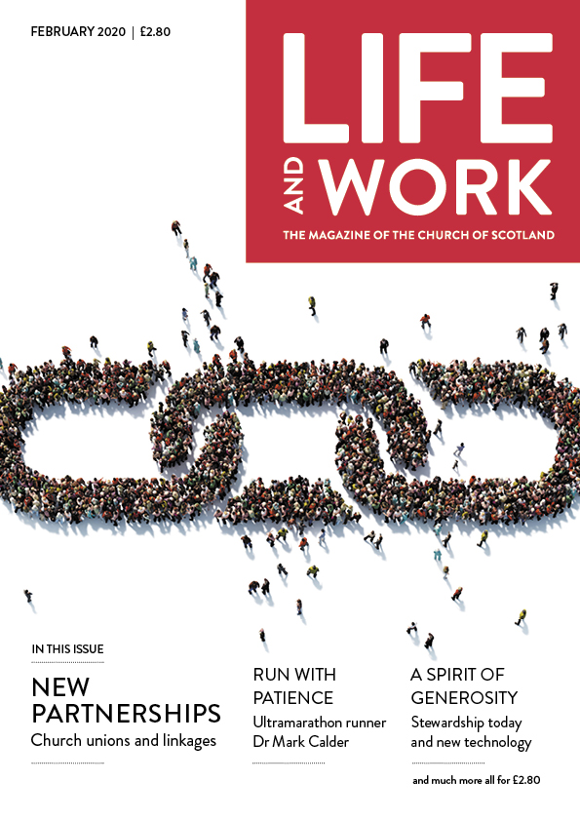

In The February Edition

NEW PARTNERSHIPS
Church unions and linkages

RUN WITH PATIENCE
Ultramarathon runner Dr Mark Calder

A SPIRIT OF GENEROSITY
Stewardship today and new technology

....plus much more packed across 60 pages

Contact Aileen or Jim Blair for any changes to your subscription.

Deadline for March’s Orchardhill Record
Sunday 16th February 2020 is the deadline for the March 2020 edition of the Orchardhill Record.
Contributions should be sent by email to Record-Team@Orchardhill.org.uk before 1.00pm or left in the relevant slot in the rack in the church corridor no later than 10.30am. Using that email address ensures that every contribution goes to the editorial team not just the editor.
We prefer contributions to be sent by email, and we cannot accept any handwritten or typed item that does not identify the source. Nor can we accept pdf files. A photograph or logo must not be embedded in the article. Please send images and inserts as separate attachments to allow flexibility in laying out pages.
You are required to ensure anyone featured in your article(s) has given consent to be identified either for the specific article, club, group or more generally for Orchardhill Record.
The editor acknowledges every contribution. Contact them before the deadline if you have not received confirmation of your contribution.

- Congregational Register

New Member: Sheila Going, September 2019

Death: Dorothy Murdoch on 21st December 2019
- Well done thou good and faithful servant. Rest safe in the Lord

Who’s Who
in the Church

- In each edition of the Orchardhill Record we aim to introduce a member of the Orchardhill community to our readers. This month, our newly appointed Youth and Family Worker, Lorna Buchan, tells us what she has been doing and a little about her plans for the future.

- Hi
- I am Lorna and I am the new Youth and Families worker here at Orchardhill. I started in November and am grateful to have been made very welcome by everybody I have met.
- Since then, I have been doing a lot of fact finding and investigating ideas to involve and enthuse the younger members of the congregation.

- In the pipeline at the moment are Messy Church and Fusion youth club. Messy Church is a brilliant enterprise aimed mainly at primary school kids and younger. Fusion will be for S1 kids onwards. Hopefully these will be exciting activities, not only for our current young congregation but for the wider community too. Watch this space for dates and times.

- Before that I am planning a community service on Shrove Tuesday - Giffnock’s Flipping Marvellous Pancake Party. Look out for clues and answers popping up in local shops, and everyone is welcome on Tuesday 25th February at 5.30pm - and, if anyone is good at making pancakes, I would really appreciate your baking skills!!

Welcomers
 | Entrance | Sanctuary | Greeters/Ushers

FEBRUARY
2 | Jim Blair | Gordon Ross | Shona Cook
9 | Shona Cook | Gordon Ross | Jim Blair
16 | Jim Blair | Dorothy Cartlidge | Irene Kinniburgh
23 | Irene Kinniburgh | Dorothy Cartlidge | Jim Blair

MARCH
1 | May Liddle | Irene Kinniburgh | Irene Kinniburgh
8 | Irene Kinniburgh | Irene Kinniburgh | May Liddle
15 | May Liddle | Jim Kerr | Jo Weir
22 | Jo Weir | Jim Kerr | May Liddle
29 | Marion Watson | Fiona Thomson | Jo Weir

Offering Teams
FEBRUARY
2 | Gordon Ross | Bruce Paterson |  | Lisel Tait
9 | Gordon Ross | Bruce Paterson |  | Lisel Tait
16 | Dorothy Cartlidge | Alan Daly |  | Norma Hannah
23 | Dorothy Cartlidge | Alan Daly |  | Hilary Kennedy

MARCH
1 | Irene Kinniburgh | David Evans |  | Nanette Davidson
8 | Irene Kinniburgh | David Evans |  | Joyce Winning
15 | Jim Kerr | Fiona Couper |  | Joyce Winning
22 | Jim Kerr | Fiona Couper |  | Norma Hannah
29 | Fiona Thomson | Margaret Howard |  | Susan McQuilter

Scripture Readers
FEBRUARY |  | MARCH
2 | Andrew Flockhart | 1 | Dave Thomson
9 | Joyce Winning | 8 | Marion Simpson
16 | Willie Hendry | 15 | Ian Anderson
23 | Fiona Thomson | 22 | Angela Peacock
 |  | 29 | George Robertson

Fun Time!

As a new decade starts, we all come to realise that it is really how we look at things that determines how we come to see them and what we put in to something that determines what we get out. Let our collective view of the glass be that it is half full.

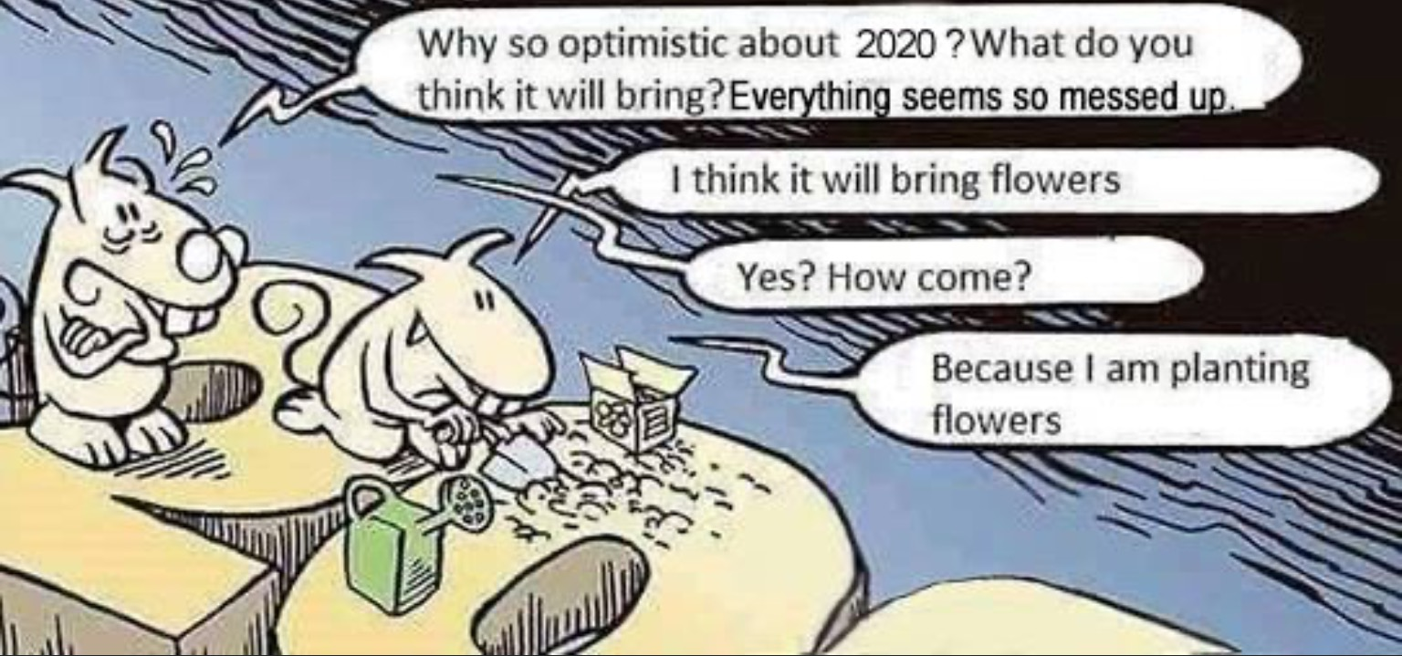

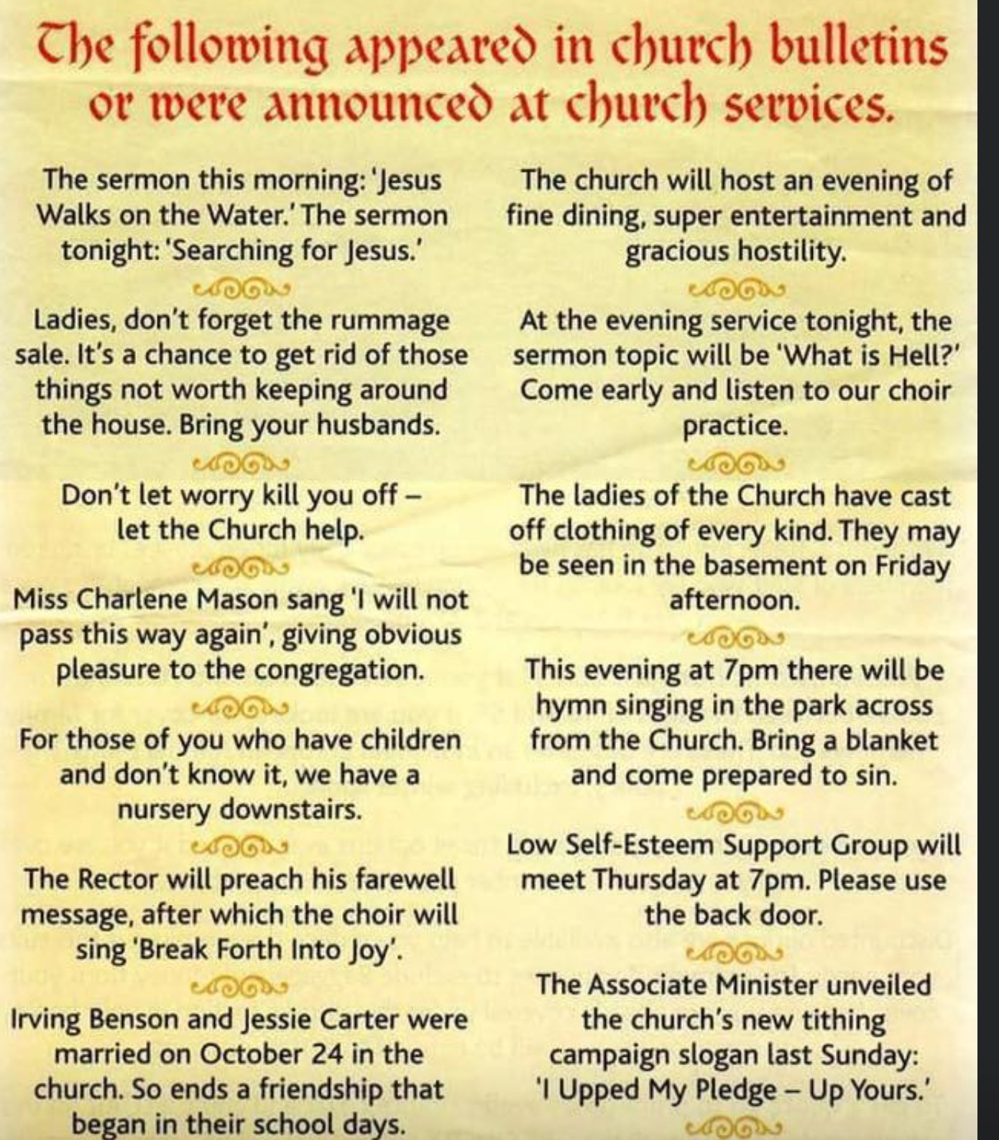

QUIZ -- KNOW YOUR HYMNS

Many composers have used the tunes of others in their works and the reverse; tunes by others have been used by composers as part of their works. Bearing this in mind this quiz requires you to do three things: first, name the composer, secondly name the composer's work which uses the theme and thirdly name the traditional hymn which uses the tune.

- This composer was a patriotic nationalist at a time when his country was a Grand Duchy of Russia; this work is often termed his country's second national anthem.

- This composer, a German who spent most of his life in London, wrote many operas and oratarios. The hymn in question uses the tune from one of his oratorios based on the life of a second century BC victorious Jewish leader.

- This American composer, famous for his "Fanfares" used this tune in one of his most popular works; it is a traditional Quaker hymn. Either of its generally accepted titles will be acceptable.

- This work is considered by many as a hymn and for the purposes of this quiz we will treat it as one. This composer used the tune in one of his works which celebrated, what is considered by many, as Britain's greatest land war victory. This year is the two hundred and fiftieth anniversary of his birth.

Be careful when answering by taking into account the year in which it was written.

This is the last quiz in series one; the same rules apply as before, if you manage to answer all four questions correctly you earn five points in total.
If any one or more participants have 25 points they will receive a book token for £30; if no one earns the maximum points but manages to score over 20 points they will receive a book token of £25.

Series 2 will start shortly.

Orchardhill Calendar

FEBRUARY
Sunday | 2 | 10.30am | Family Worship | Rev Grant Barclay
Sunday | 9 | 10.30am | Family Worship & Sacrament of Baptism | Rev Grant Barclay
Sunday | 16 | 10.30am | Family Worship | Rev Grant Barclay
Tuesday | 18 | 7.30pm | Kirk Session | Rev Grant Barclay
Sunday | 23 | 10.30am | Family Worship | Rev Grant Barclay
Sunday | 23 | 7:30pm | Film Night – Father of the Bride
Saturday | 29 | 8.30am - 10.00am | Local Church Breakfast
MARCH
Sunday | 1 | 10.30am | Family Worship | Rev Grant Barclay

Orchardhill Parish Church, Church Road, Giffnock Glasgow G46 6JR
phone 0141 638 3604
website: www.orchardhill.org.uk
email: secretary@orchardhill.org.uk

Orchardhill Parish Church: Scottish Charity number SC 009774

