How to add non availability for rotas etc to your iknow profile.

Log into iKnow in the normal way.
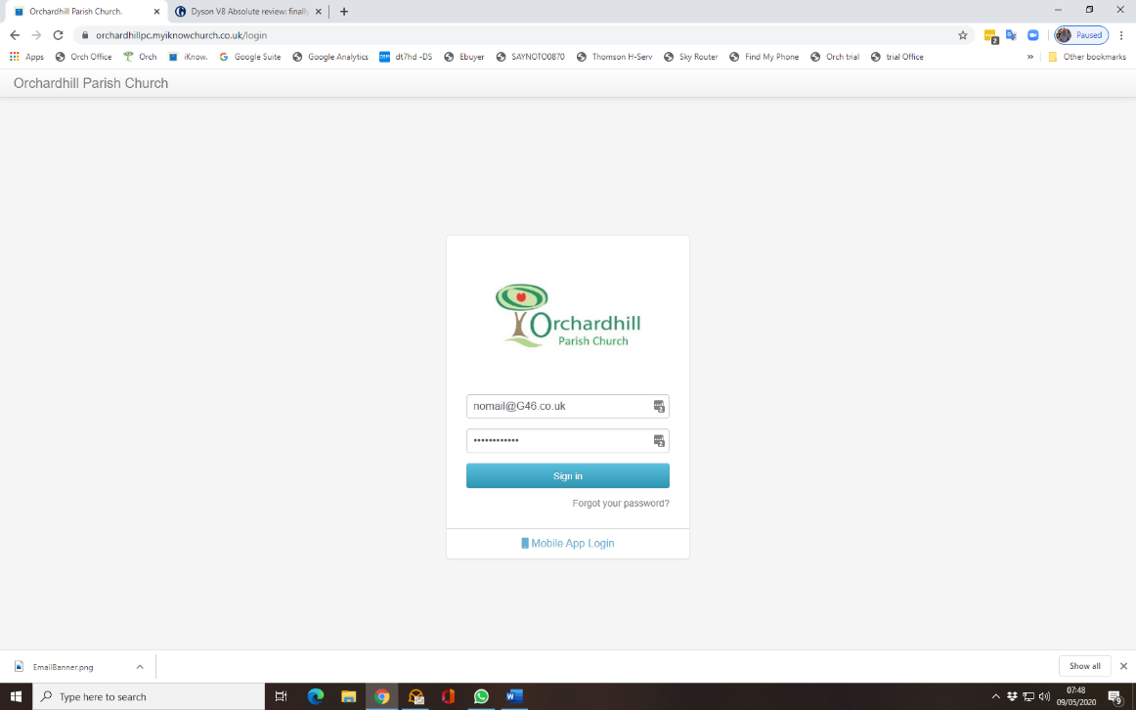
From the dashboard choose ME on the top left next to the round speedo.
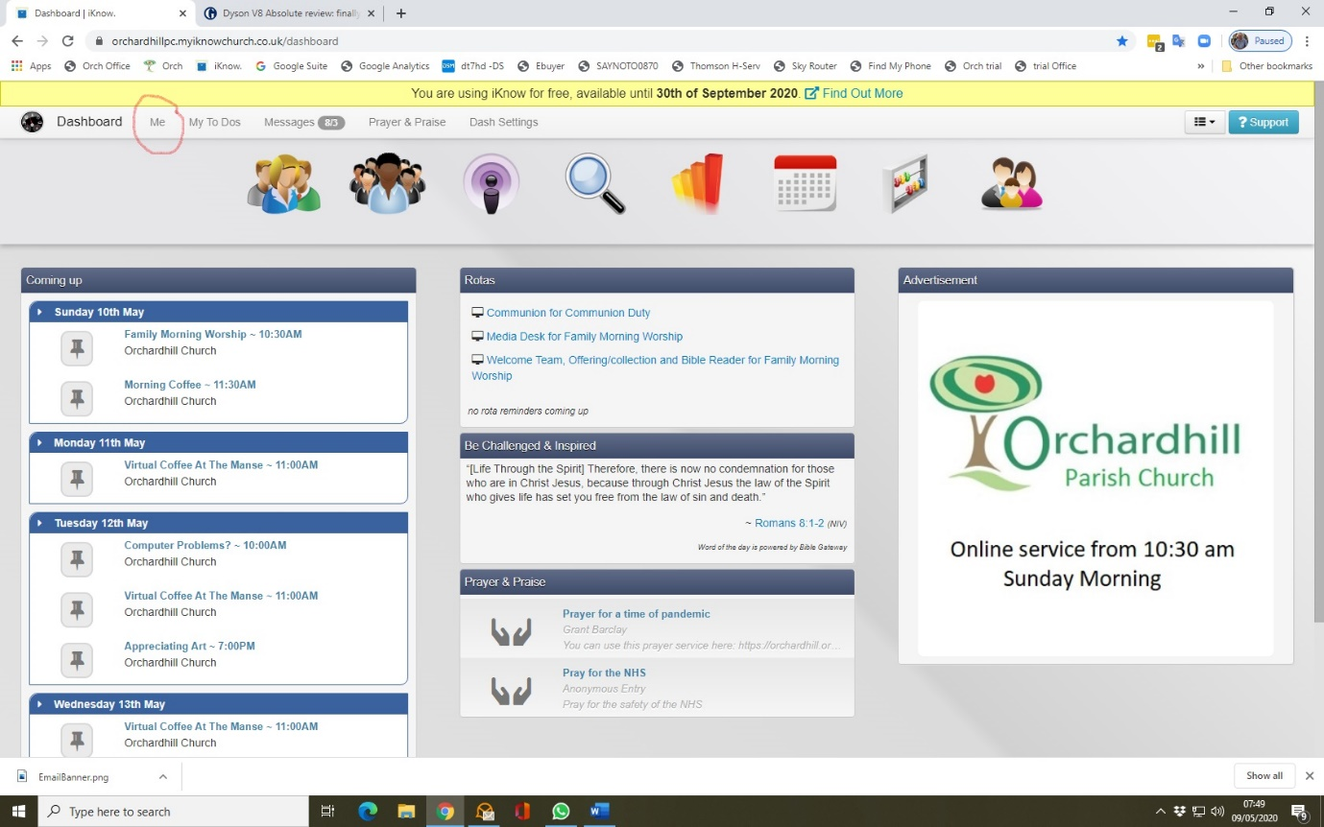

Once you have your profile then click on Add Holidays
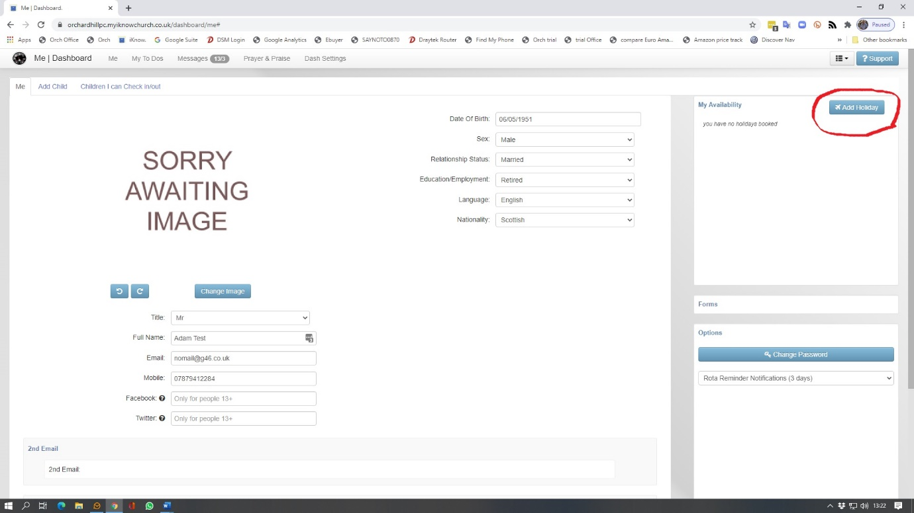
Enter your dates and description e.g. Staying Online.
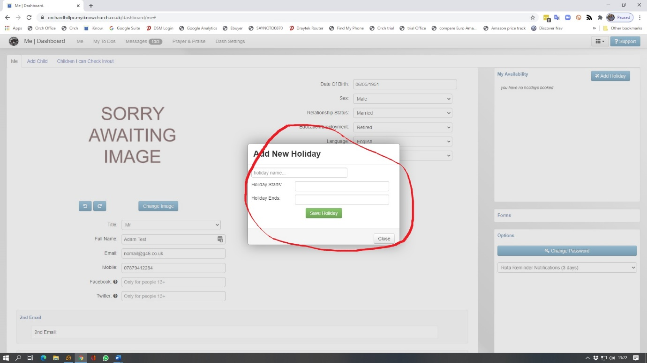
Once completed click Save

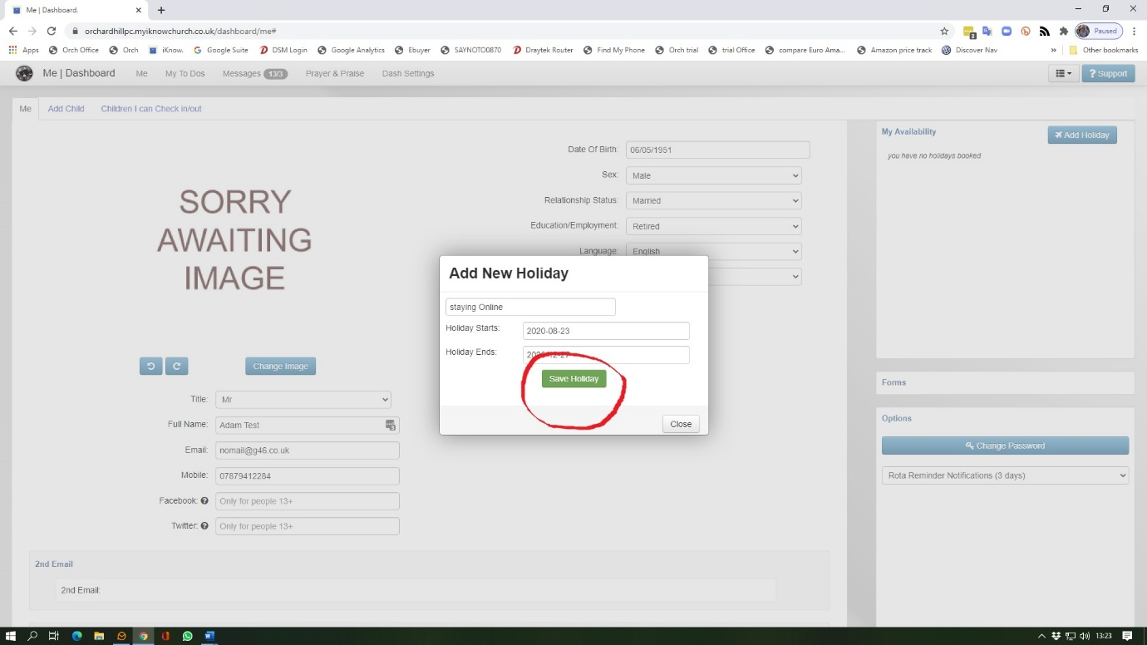

Your availability is now on the system and you won’t be asked to do rotas between those dates, unless you have indicated that you will record your reading/prayer for the online services.
While you are in your profile you can also set the number of days advance notice you get for rota duties. The default is 3 but you can change this to suit yourself e.g. if you set it to 8 then you won’t be surprised when the minister sends you an email 7 days before your duty requesting that you do a reading or create a prayer.
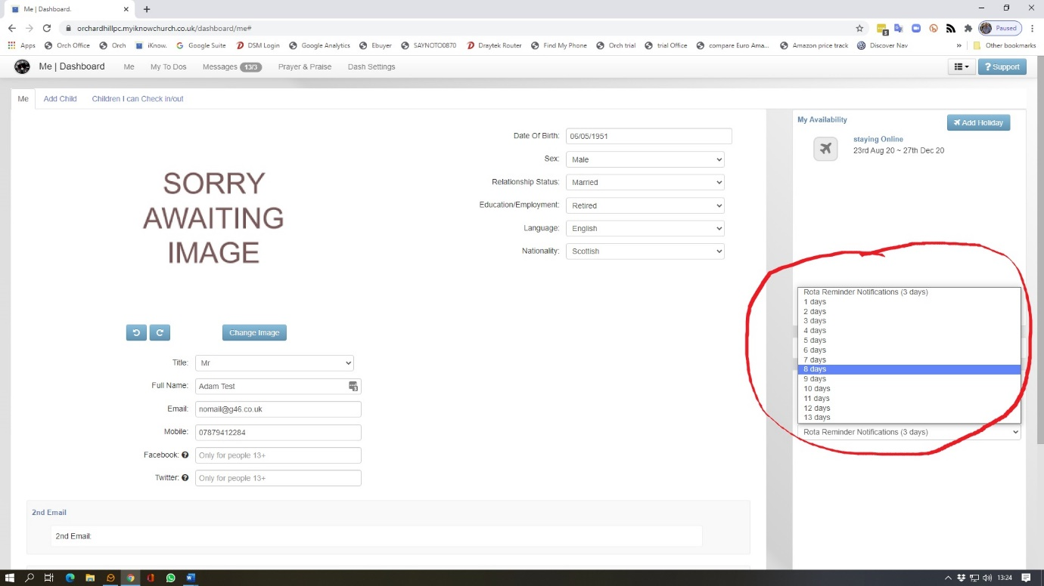
Adjust if required
You can also add an image of yourself on this page simply click on the appropriate place and follow the instructions
Once all your amendments are complete then go to the bottom of the page and click Save. Note that you can change the way we get in touch e.g. You may not want calls to the house, rather only to your mobile uncheck home phone. DO NOT UNCHECK EMAILS as this is the primary way the church keeps in touch with office bearers. To Finish Click SAVE
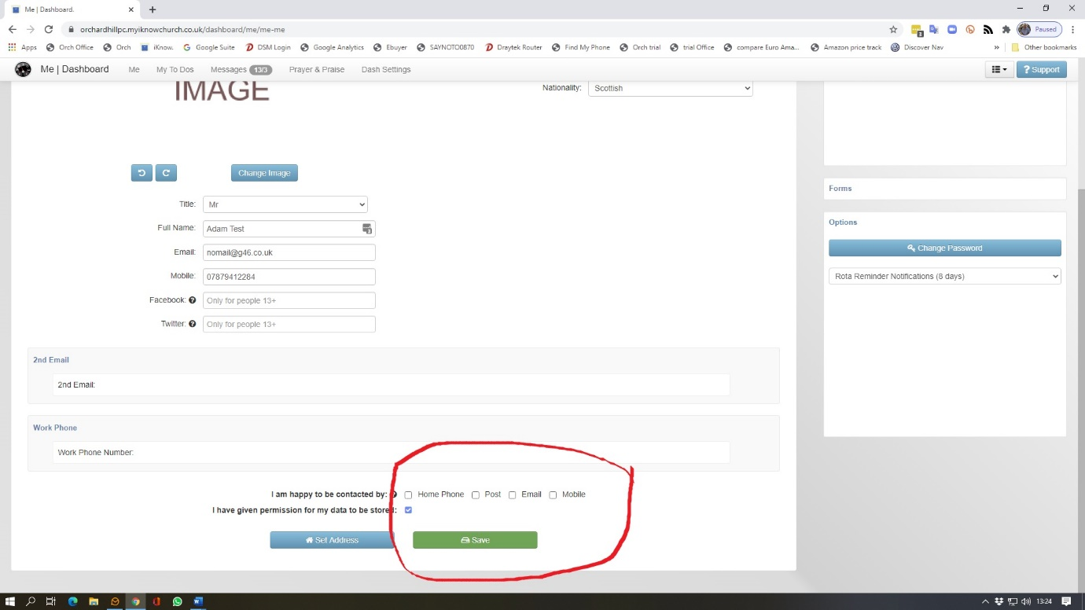
Your Profile will update
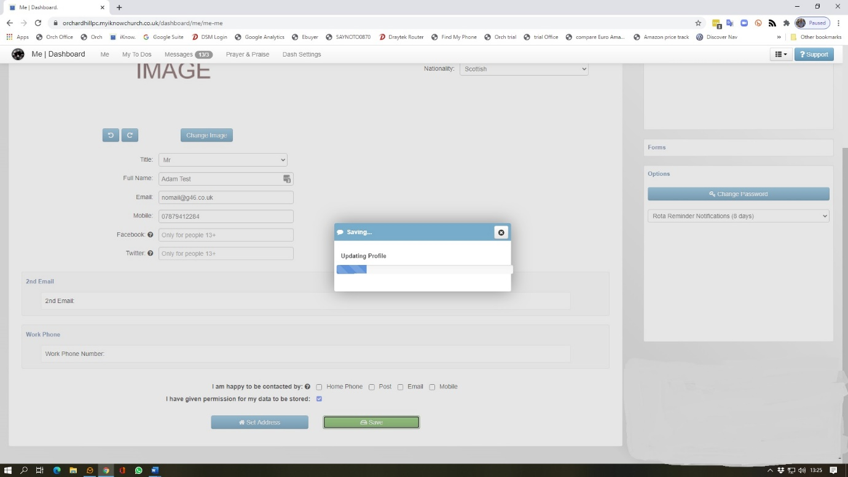
Close all windows and exit. Don’t forget you can view all your rota duties from the dashboard of iKnow Church.

Updating Via the iKnow Church App
You can also add holidays etc via the iKnow app.

Open up your I Know Church app
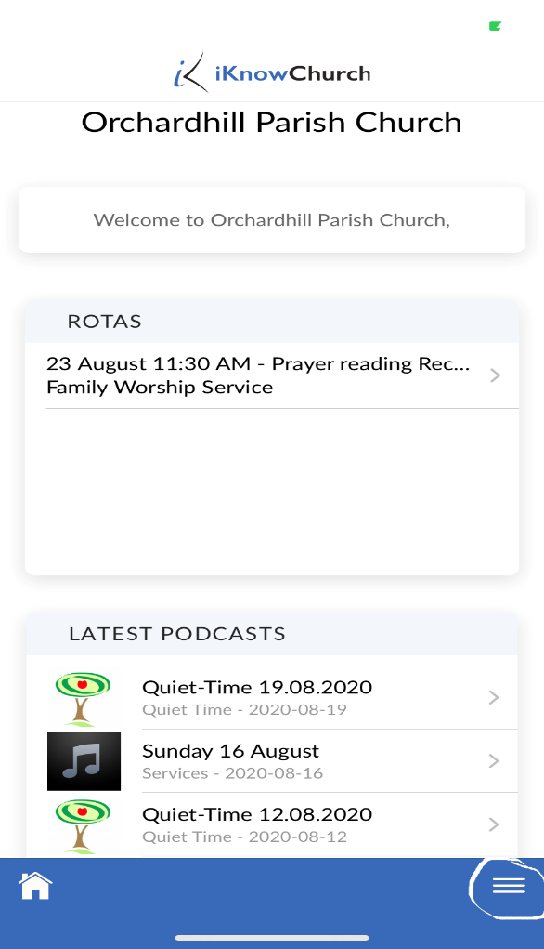
At the bottom of the page is the menu symbol (three lines) press this.
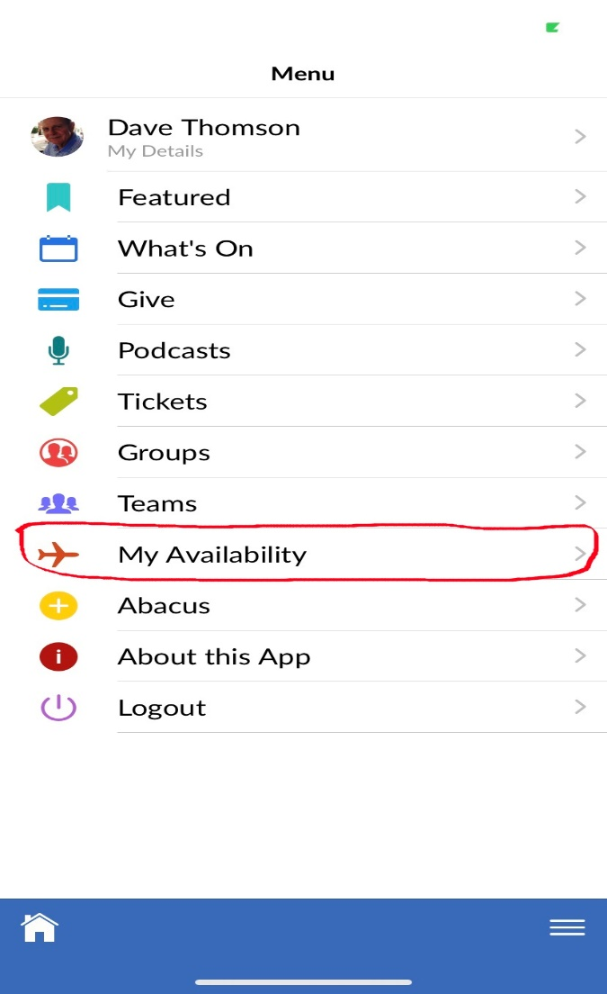
From the menu select My Availability
Press add reserved period
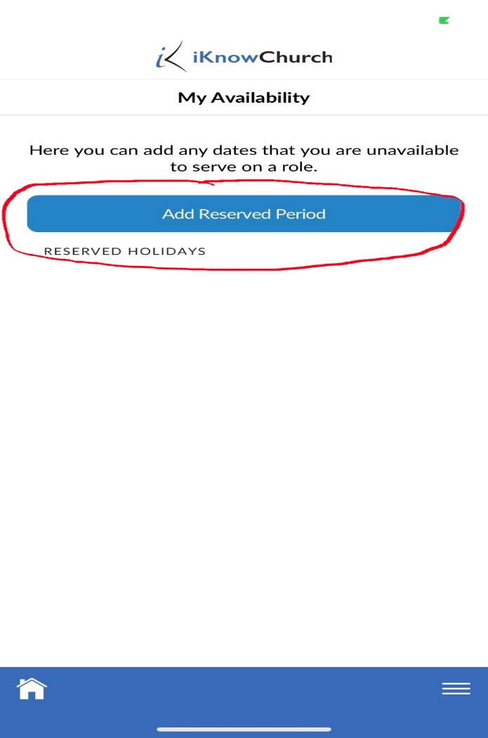
Enter a title and choose your dates once you are happy press SAVE
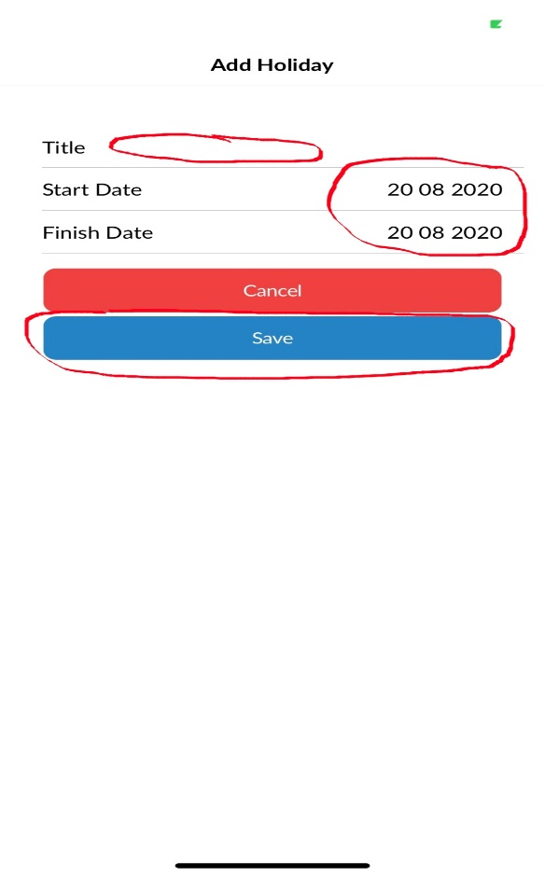

When you return to the My Availability page then you will see the updated information.

